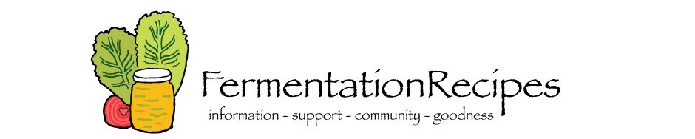
Fermenting Class
Saturday - April 22, 2017

You’ve probably heard of probiotics—they are healthy bacteria that help our digestive tracts and keep us healthy. But what you may not know is that fermented foods sitting on a grocery store shelf may not contain many (if any) of those good bacteria.
Want to be sure your fermented foods are fresh, delicious, and bacteria-rich? Turn to home fermentation! As complicated as it sounds, it turns out at-home fermentation is cost-effective, simple, and fun! We are having a class to have fermentation experts teach the ins and outs of at-home fermentation. You will be lead through the process of making your own fermented foods at home.
The class will be held at Dr. Koe’s Farmstead.
When: Saturday April 22, 2017
Address: 1676 County Road 12, Collinsville, AL
Time: From 9:00 am until Noon
Maximum class size is 10 so reserve your spot early!!
Please reserve my spot for Dr. Koe’s fermenting class on April 22, 2015 from 9:00 – 12:00 pm.
Please check whichever applies:
- I will need a 2 liter wide mouth canning jar with lid $50. (This price includes supplies, jar and lid with airlock)
- I will bring my own wide mouth jar $43. (This price includes supplies and 4 plastic lids with airlocks)
We need to order the jars and lids by April 7th in order to receive the jars in time for the class. Please drop this reservation and payment for either the jar or lids to our Clinic by April 7, 2017.
Name: E-mail: @
Phone number: Amount enclosed:

